[](https://www.google.com/url?sa=i&url=https%3A%2F%2Fcitizensadvicesnpt.org.uk%2F&psig=AOvVaw1hqxyLYVAu27yOJ_GsYN-_&ust=1585393417402000&source=images&cd=vfe&ved=0CAIQjRxqFwoTCMiF-_fAuugCFQAAAAAdAAAAABAT)

A GUIDE TO BEREAVEMENT AND LOSS

IN RESPONSE TO THE COVID 19 SITUATION

Developed by

Neath Port Talbot Educational Psychology Service and School Based Counselling Service

April 2020

[](https://www.google.com/url?sa=i&url=https%3A%2F%2Fwww.cheshire.media%2F2018%2F11%2F14%2Fchildhood-bereavement%2F&psig=AOvVaw0ixJsk3RzUfdSYHO-uH5cD&ust=1585658144635000&source=images&cd=vfe&ved=0CAIQjRxqFwoTCICcn6SbwugCFQAAAAAdAAAAABAE)

The Impact of COVID 19 and Bereavement and Loss

During the global COVID 19 pandemic we are facing a tragic loss of life, often under very difficult circumstances. All children will have questions about the effects of the virus but for children who have had someone important die or have a member of their family who is ill, this anxiety is likely to be heightened. Bereaved children, or those who have a member of their family who is ill, are likely to be anxious about coronavirus. After someone important dies, children will be very worried about the health of their surviving family. It is natural for a child whose parent has died, for example, to be worried that something bad will happen to the other parent.

Children often gain comfort and normality from interacting with their peers when they have been bereaved. However, at this time adults are being encouraged to work from home, schools have closed, families are staying at home and children are often not seeing their friends and relatives. With the current restrictions around funerals due to coronavirus, children and young people may not be able to attend the funeral of a loved one.

We have drawn together these resources to consider how children understand death and how bereavement and grief may be affected by the COVID 19 situation. There are resources to support schools and parents to think about how best to support the children during this unprecedented time and to help children to say goodbye.

We have provided resources which may be helpful when considering the sharing of information regarding the death of a member of school staff or a child with within the school community.

Should you require any further advice please contact the Educational Psychologist or School Based Counsellor for your school. ~~who are still available even while schools have been closed.~~ Please find a list attached in the Appendices.

Alternatively you can contact:

* Zoe Ashton – Principal Educational Psychologist – [z.ashton@npt.gov.uk](mailto:z.ashton@npt.gov.uk)
* Rhian Miller – Senior School Based Counsellor - [r.tyler@npt.gov.uk](mailto:r.tyler@npt.gov.uk)
* Alison Annear – Senior Educational Psychologist – [a.annear@npt.gov.uk](mailto:a.annear@npt.gov.uk)

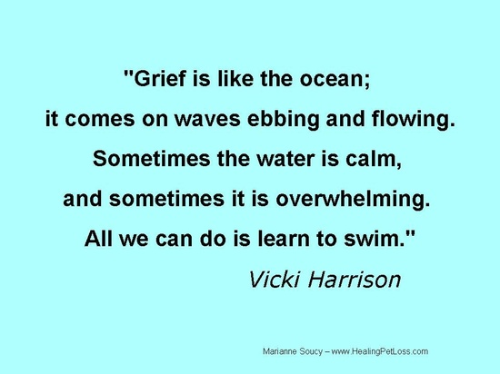

Contents To complete…

Page

|  |  |
| --- | --- |
| Page | The Impact of COVID 19 and bereavement and loss |
| Page | Stages of Grief |
| Page | The Grief Cycle Model |
| Page | What factors affect the grieving process? |
| Page | How do children and young people understand death? |
| Page | Strategies and support for loss and bereavement - School Based counselling  Service               How to access Support from a SBC… |
| Page | Breeavement and ASD |
| Page | Writing a Social Story about the death of a loved one |
| Page | Resources and strategies to help a child with loss and bereavement. |
| Page | Supporting parents re supporting their bereaved child… with ideas and resources and links??  To support parent and child together e.g. Winston’s Wish, memory boxes etc. |
| Page | How should schools share information regarding the death of a member of the school community?  How to inform parents of the death of a teacher – sample letter??  How to inform parents of the death of a child – sample letter?? |
| Page | Sharing Information on the Death of a Member of the School Community |
| Page | COVID 19 Funerals and Memorials |
| Page | Books and websites to support a bereaved child and family |

The Stages of Grief

Factors which can influence the grieving process

|  |  |
| --- | --- |
| Relationships | A young person’s response to the death of someone close will vary according to the nature of their relationship. It is important to recognise that losing someone who has played an important role in their life will have more impact on a child than losing someone who has had little to do with them. For example, a child may grieve more for the next door neighbour who has looked after them every day after school than for a grandparent who lives in Australia who they have never met. |
| Cause of death | No cause of death is better or worse than another for a grieving child, although there are different issues to consider depending on the circumstances.  If the family member was ill, the death may have been expected, the family may have had time to prepare. However, it is also important to recognise that this period would have been a stressful time for the child/young person.  If the death is sudden, there is no opportunity for goodbyes and no time to prepare for the death. Due to the restrictions on visiting in place due to COVID-19, family members may not have had the opportunities to visit ill family members. |
| Reaction of Family Members | Children and young people learn to grieve by watching others. If parents attempt to keep their emotions under control, children may feel it is inappropriate to show their own.  Equally, it is difficult for children and young people to share their feelings with a parent who is overwhelmed by their own grief. In this situation, the child/young person may try to suppress their emotions so they don’t distress their parent further.  Children/young people may take on the responsibility of being a carer within the family, and their own needs may be overlooked. |

The Grief Cycle Model

Elisabeth Kübler-Ross (1969) developed the Grief Cycle model. This model explored five stages of grief; denial, anger, bargaining, depression and acceptance. These are a part of the framework that makes up our learning to live with the one we lost. They help frame and identify what someone may be feeling. But they are not stops on some linear timeline in grief. Not everyone goes through all of them or in a prescribed order. The hope is that each stage makes an individual better equipped to cope with life and loss. At times, people in grief will often report more stages.

Just remember grief is as unique as each individual.

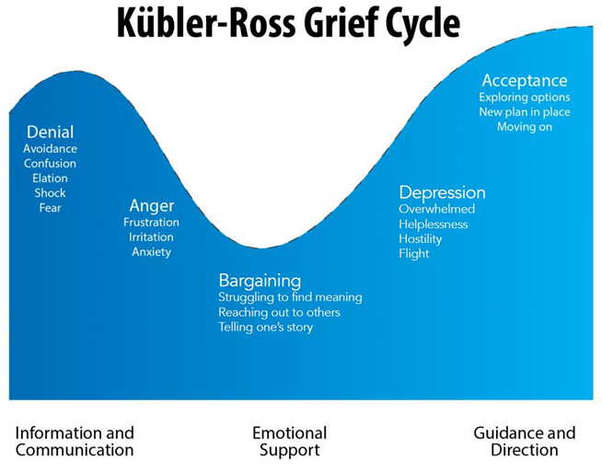

|  |  |  |
| --- | --- | --- |
| DENIAL | The Five Stages of Grief  C:\Users\ed961\AppData\Local\Microsoft\Windows\INetCache\Content.MSO\880EAC16.tmp | Denial is the first of the five stages of grief. It helps us to survive the loss. In this stage, the world becomes meaningless and overwhelming. Life makes no sense. We are in a state of shock and denial.  Denial is a conscious or unconscious refusal to accept facts, information, reality, etc., relating to the situation concerned. It's a defence mechanism and perfectly natural. Some people can become locked in this stage when dealing with a traumatic change that can be ignored. Death of course is not particularly easy to avoid or evade indefinitely.  Denial helps us to pace our feelings of grief. It is nature’s way of letting in only as much as we can handle. As we accept the reality of the loss and start to ask questions, this allows us to unknowingly beginning the healing process. We become stronger, and the denial is beginning to fade. But as you proceed, all the feelings that we were denying may begin to surface. |
| ANGER | C:\Users\ed961\AppData\Local\Microsoft\Windows\INetCache\Content.MSO\FD6BD2A1.tmp | Anger is a necessary stage of the healing process. We must be willing to feel anger, even though it may seem endless. The more it is truly felt, the more it will begin to dissipate and the more we will heal.  Anger can manifest in different ways. People dealing with emotional upset can be angry with themselves, and/or with others, especially those close to them. Knowing this helps keep detached and non-judgmental when experiencing the anger of someone who is very upset.  The truth is that anger has no limits. It can extend not only to friends, the doctors, family, yourself and the loved one who died, but also to God. Underneath anger is pain.  It is natural to feel deserted and abandoned, but we live in a society that fears anger. Anger is strength and can be something to hold onto; and a connection made from the strength of anger feels better than nothing. We usually know more about suppressing anger than feeling it. The anger is just another indication of the intensity of your love. |
| BARGAINING | [Pin by pooja on Emoticon | Emoji images, Emoji pictures, Emoji symbols](https://www.google.co.uk/imgres?imgurl=https%3A%2F%2Fi.pinimg.com%2F736x%2Fb9%2Fa4%2F58%2Fb9a458e94d7a322630cce028b6046abd.jpg&imgrefurl=https%3A%2F%2Fwww.pinterest.com%2Fpin%2F38702878033879191%2F&tbnid=b1B-JKC97K1cZM&vet=12ahUKEwiZ88rt27roAhUKZxoKHV4LAbQQMygbegQIARBb..i&docid=pcUxDUDVPHHpbM&w=668&h=518&q=emoji%20praying%20&ved=2ahUKEwiZ88rt27roAhUKZxoKHV4LAbQQMygbegQIARBb) | Traditionally the bargaining stage for people facing death can involve attempting to bargain with whatever God the person believes in. It seems like we will do anything if only your loved one would be spared. “Please God…” we bargain. After a loss, bargaining may take the form of a temporary truce.  We want life returned to what is was; we want our loved one restored. We want to go back in time…if only, if only, if only. Guilt is often bargaining’s companion. The “if onlys” cause us to find fault in ourselves and what we “think” we could have done differently. We may even bargain with the pain. We will do anything not to feel the pain of this loss. We remain in the past, trying to negotiate our way out of the hurt. |
| DEPRESSION | C:\Users\ed961\AppData\Local\Microsoft\Windows\INetCache\Content.MSO\62F76278.tmp | Depression or sadness is a sort of acceptance with emotional attachment. It's natural to feel sadness and regret, fear, uncertainty, etc. It shows that the person has at least begun to accept the reality.  Empty feelings present themselves, and grief enters our lives on a deeper level, deeper than we ever imagined. This depressive stage feels as though it will last forever. It’s important to understand that this depression is not a sign of mental illness. It is the appropriate response to a great loss.  The loss of a loved one is a very depressing situation, and depression is a normal and appropriate response. To not experience depression after a loved one dies would be unusual. When a loss fully settles in your soul, the realization that your loved one didn’t get better this time and is not coming back is understandably depressing. If grief is a process of healing, then depression is one of the many necessary steps along the way. |
| ACCEPTANCE | C:\Users\ed961\AppData\Local\Microsoft\Windows\INetCache\Content.MSO\43DB3A75.tmp | This stage can definitely vary according to the individual situation, although broadly it is an indication that there is some emotional detachment and objectivity.  Acceptance is often confused with the notion of being “all right” or “OK” with what has happened. This is not the case. Most people don’t ever feel OK or all right about the loss of a loved one. It’s important that the child/young person knows this is ok.  This stage is about accepting the reality that our loved one is physically gone and recognizing that this new reality is the permanent reality. We will never like this reality or make it OK, but eventually we accept it. We learn to live with it. It is the new norm with which we must learn to live.  We must try to live now in a world where our loved one is missing. In resisting this new norm, at first many people want to maintain life as it was before a loved one died. In time, through bits and pieces of acceptance, however, we see that we cannot maintain the past intact. It has been forever changed and we must readjust.  Finding acceptance may be just having more good days than bad ones. As we begin to live again and enjoy our life, we often feel that in doing so, we are betraying our loved one. We can never replace what has been lost, but we can make new connections. We begin to live again, but we cannot do so until we have given grief its time. |

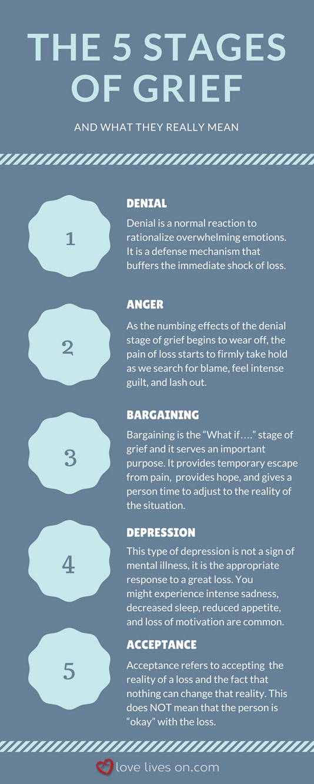

Do we need this?

**Traumatic loss**

When someone we care about dies in a sudden and/or traumatic situation, there are additional problems which add to the grieving we feel when anyone we love dies. You may have witnessed the death, or the deaths and injury of others. Everyone's experience and responses will be different and there is no right or 'normal' response. However there are some common reactions and feelings you may experience in the hours, days, weeks and months after a traumatic event. These feelings can sometimes be very strong and frightening.

There are four main types of problems which may arise after someone close to you dies in a traumatic circumstance:

* [**Problems of trauma**](https://www.cruse.org.uk/get-help/traumatic-bereavement/traumatic-loss#Problems%20of%20trauma)
* [**Problems of grieving**](https://www.cruse.org.uk/get-help/traumatic-bereavement/traumatic-loss#Problems%20of%20grieving)
* [**Problems of anger and self-reproach**](https://www.cruse.org.uk/get-help/traumatic-bereavement/traumatic-loss#Problems%20of%20anger)
* [**Problems of change**](https://www.cruse.org.uk/get-help/traumatic-bereavement/traumatic-loss#Problems%20of%20change)

**Problems of Trauma**

**I can’t believe it’s true'**

**What helps?**

It takes a long time to take in what has happened. Spend time talking it through with others and don’t worry that you are being a burden to them, that’s what friends are for.

**Problems of Grieving**

**'I feel numb'**

Numbness is our mind’s way of protecting itself from mental pain that threatens to overwhelm us. Sometimes we may be unable to think clearly, or become confused and lose our bearings. At other times we may be unable to express feelings of any kind.

**What helps?**

Grief is the natural response to the loss of a loved person. It is more likely to give rise to problems if it is bottled up than if it is expressed. At times of loss it is normal and appropriate to express grief in any way that feels natural. Some people need to cry, others will rage and others just talk endlessly about what has happened. Try to find someone you can trust who will be a good listener and don’t worry if, for a while, you look or feel helpless, that will pass.

**'I can’t stop crying'**

**What helps?**

Grief is not like the measles, we do not go back to being the person we were before our loss. We learn to live with it, and, little by little, the pain will diminish. Grief is not a duty to the dead, those we love would not want us to suffer. Again, talking it through with a friend or counsellor will help. Don’t give up

**Problems of Anger and Self-Reproach**

**'I feel so angry'**

Anger is a very natural reaction to loss, particularly if the loss happened un-expectedly. Some people may find themselves hitting out wildly at the people they love the best.

**What helps?**

Remember that anger can be a force for good if it is controlled and directed where it can do well rather than harm. Try to hold back from impulsive outbursts and, if you have said or done things that have hurt others, don’t be too proud to apologise. They will understand.

**'I blame myself, I feel so guilty'**

Often, people end up blaming themselves. At the back of our minds we may even cling to the idea that, if we punish ourselves we will make things right again and get back the person we have lost. Sadly this magical thinking is doomed to fail.

**What helps?**

Sooner or later we have to accept that what has happened is irrevocable and that punishing ourselves won’t change anything. Friends will often say ‘You shouldn’t blame yourself’, and maybe they are right. But you do not choose the way you feel. Guilt and anger are not feelings that can be switched on and off at will.

**Problems of Change**

**'I feel so frightened'**

We all know that disasters happen, but most of the time we go through life with confidence that we are safe, protected from harm and immune from significant trauma. Then disaster strikes, all in a moment the world has become a dangerous place, we can take nothing for granted, we are waiting for the next disaster.

**What helps?**

The first and most important thing is to recognise that the symptoms of fear are a sign of normality, at such times a racing heart is a normal heart, headaches, back aches, indigestion, even feelings of panic, are natural reactions that will decline as time passes, they are not symptoms that will lead to something worse. In addition you are not as helpless as you feel. Relaxation exercises, meditation techniques, aromatherapy or whatever helps to relax you will put you back in control.

**Life has lost its meaning'**

Each person’s sense of purpose and direction in life arises from a hundred and one habits of thought and assumptions about the world that we take for granted. Then, all of a sudden, we can take nothing for granted any more. Perhaps the person who died is the one we would have turned to at times of trouble and now, when we face the biggest trouble in our lives, they are not there, or, if they are, they are so overwhelmed by their own grief that we cannot burden them with ours.

**What helps?**

Those who have a religious faith may find it helpful to seek pastoral support; others may find spiritual help outside of formal religious frameworks.

We feel as if we had lost every good thing that relied on the presence of the person we love for its meaning. But take heart, all is not lost. Now is the time to take stock, and ask yourself what really matters?

When we do that we may be surprised to find that many of the things that made sense of our lives when the lost person was with us continue to make sense of our lives now that they are away. Indeed they may make more sense because they are away. When people say 'He (or she) lives on in my memory', this is literally true.

What factors affect the grieving process?

It is important to remember that each child and young person’s reaction will be different and may change over time. Grief doesn’t follow a set pattern of responses, and reactions will depend on many things including:

* **How old they are:** their age and stage of development. The child’s age will have a large influence on how you communicate with the child. As children learn, grow, and mature, their capacity to understand will change and evolve. For instance, when speaking with small children you will want to stick with straightforward and simple answers, while when speaking with teens you may explore more complex and abstract concepts.
* **How close they were to the person who died**: their relationship with the person who died.

Closeness can be defined in two ways (1) when the child was very close to the deceased such as with a parent, grandparent, or sibling or (2) when the memory of the deceased is a constant presence, even though the child may not have had a close relationship with the person. Examples of this second scenario include any close family member, like a grandparent, sibling, or parent, who died before the child was able to build a relationship with them.

If the person who died was not a close family member, friend or community member, you may find that having one or two conversations is all that is necessary. If the person who died was a close family member or friend or community member, then you should conceptualize your first conversation as the beginning of an ongoing dialogue, rather than as a single conversation.

Although initial conversations about the death may not be detailed, expect that as the child processes the loss, and as their capacity to question and understand matures, they may (1) want to know more about their loved one (2) want to know more about the circumstances of the death and (3) want to talk about their loved one as a way of maintaining their ongoing bond

* **How curious they are:** If the child has questions, it’s a sign that they are curious, that they don’t understand, or that they are seeking reassurance. Remember, grief is an ongoing process and that your child may continue to process the death long after your conversation with them has ended. Allow the child to ask questions within the context of your conversation(s) and make sure they know it’s okay to ask questions later on if they come up. Don’t be surprised if children ask the same questions over and over, they may want to clarify their understanding or they may want reassurance that the story hasn’t changed. If you think it may be helpful, you and the child can also discuss other adults they feel comfortable going to with questions (such as an aunt or uncle, adult sibling, faith leader, etc).
* **The nature of the death:** How someone died will affect a child’s response. A sudden death allows no time to prepare for what happens, no opportunity to say goodbye. There is also a feeling of being left suspended, or with unfinished business. When a parent or sibling dies unexpectedly in a road accident, or even more traumatically through murder or suicide, the immediate reaction is shock and total numbness. Young people may feel immense pain at their loss, and anger with the person who has died and left them. Frustration at missing out on planned activities together, which can now never happen, is another response. They may have bitter regrets about something they said, or wish they had said, but never got the chance.
* Other factors to consider include:
  + the family circumstances
  + their religion or culture
  + their previous experience
  + the behaviour of adults around them.

How do children and young people understand death?

Here is a list of typical grief responses by age. Every child is different and all the unique and individual qualities of your child can’t be quantified in this list. If your child reacts in a way that concerns you then it might be a good idea to talk things over with a GP, school counsellor, or educational psychologist.

**Typical Grief Reactions by Age:**

**0-1 year:**

* They have no ability to conceptualize death
* Their memory capacity for specific relationships is undeveloped. Unless the person who died was a close caregiver, they may have very little response.
* They may be aware that something is different or missing.

**1-2 years:**

* Children younger than 2 years old do not understand the concept of death.
* They are concrete thinkers. It may feel callous to explain death in a straightforward way, but metaphors and euphemisms will be confusing. Provide simple and clear explanations.
* When someone dies, they are likely to show behaviours associated with separation anxiety, e.g. looking for the person and crying.  If they are old enough to ask, they may inquire where the person is or when they will be back.
* They probably won’t understand there are factors beyond our control and won’t understand why the person chose to leave, particularly if the person who died was an adult. Make sure to explain that death and leaving were not things their loved one chose.
* They are not too young to sense the stress and emotion felt by grownups in their lives.
* Sticking to their normal routine may provide a sense of security, normalcy, and comfort.
* Give them attention and provide them with reassurance.

Signs of distress may include increased irritability and crying, changes in eating and sleeping patterns, and/or withdrawing. If these or any other behaviours concern you, you may want to discuss them with their GP or seek outside counselling.

**2-4 years:**

* They still don’t understand the finality of death and still might see it as abandonment.
* They see death as reversible or not permanent. Dead people are simply sick or asleep and can get better or wake up.
* They may ask the same questions over and over; be patient and stick with the same straightforward explanation.
* They may not have the words to explain how they are feeling. You are likely to see expressions of grief through behaviour and through play with toys and/or drawing.
* They may experience separation anxiety. When you must leave the child, it might be helpful to prepare them in advance that you will be leaving and provide them with reassurance about when you will return.
* They may feel the person’s absence in an intense way one moment and be back to happily playing the next.
* They will be aware of changes in patterns and routine. Provide them with a lot of reassurance, nurturing, and consistency.

Signs of distress may include regressive behaviours in the areas of sleep, potty training, and/or eating. They may become clingy. They may appear irritable, confused or suffer from nightmares. If these or any other behaviours concern you, you may want to discuss them with their GP or seek outside counselling.

**4-9 years:**

* They are starting to develop the ability to feel guilt. Guilt can be confusing for them and they may feel guilty for odd things.
* “Magical Thinking” is seen around 4 years old. This is when children believe their thoughts and wishes can cause things to happen. For this reason children may irrationally feel responsible for the death because of thoughts or wishes they had prior to the death. (Example: I’m responsible for the death because I told my mum I hated her and wished she would go away).
* They may be interested in the process of dying and ask ‘how’ or ‘why’ things have happened. Their questioning may be repetitive.
* They have begun to understand that death is not reversible or temporary, but still may believe that death only happens to some people and will not happen to them.
* Death is often personified as things like ghosts and monsters.
* They lack the words to express their emotions. They may have strong feelings of grief and loss but can’t express this in appropriate ways. They may express feelings through anger and frustration.
* Symbolic play using drawings and stories can be helpful.
* They may need permission and encouragement to grieve. Encourage expression of feelings through talk, play, or physical outlets.

Signs of distress may include regression, nightmares, sleep disturbances, and/or changes in eating. They may engage in violent play. They may try to take on the role of the deceased. If these or any other behaviours concern you, you may want to discuss them with their GP or seek outside counselling.

**9-12 years:**

* They understand the finality of death and that everyone eventually dies, however they still may engage in denial that it will happen to them (don’t we all?)
* They are curious about the physical aspects of death – what does the body look like? What does it feel like? etc. Provide straightforward explanations.
* They know how to express their feelings and emotions, but they may choose not to. Encourage them to express the range of feelings they are having.
* They may be concerned with how others are reacting to the death. What is the right way to react? How should they react?
* Involve them. Allow them to give input and make choices regarding funerals, memorials, belongings, etc.

Signs of distress may include having problems at school, withdrawing from friends, acting out, disturbances in sleeping and eating, an overwhelming concern with the body, and/or role confusion. If these or any other behaviours concern you, you may want to discuss them with their GP or seek outside counselling.

**12-20 years:**

* They are capable of having a more adult perspective of death.
* Involve them. Allow them to give input and make choices regarding funerals, memorials, belongings, etc. It is acknowldeged that this will be difficult during the COVID 19 situation.
* They are able to think abstractly about death and related concepts such as afterlife.
* They may try to make sense of things, philosophise, and/or search for meaning.
* Their mourning may be more traditional – extreme sadness, anger, denial. Even though they are capable of expressing grief they may chose not to.
* They may work to give the appearance they are coping well when they are not.
* They may feel forced to act as a consoler and comforter for younger children or adults.
* Be available, listen, and encourage them to talk about it. Do not attempt to minimize what they are feeling.
* Set a good example by speaking about your own feelings surrounding the death (without putting them in the role of the comforter).
* They may be more willing to talk about grief with people outside of the family. Grief support groups may be helpful.
* They may act out or engage in dangerous behaviour such as risk taking, drugs, alcohol, etc.

Signs of distress may include having problems at school, depression, anger, suicidal thoughts, rule breaking, role confusion, and/or acting out. If these or any other behaviours concern you, you may want to discuss them with the school counsellor or GP or seek outside counselling.

Strategies and Support for Loss and Bereavement

**Supporting yourself as a young person. Other**

It is important that you take care of yourself following a bereavement.

One of the most helpful things is to talk about the person who has died and your relationship with them. Who you talk to will depend on you. It may be your family, friends, a faith/spiritual adviser, your GP or a support organisation.

**Do…..**

* Talk to other people about the person who has died, about your memories and your feelings.
* Look after yourself. Eat properly and try to get enough rest (even if you can’t sleep).
* Give yourself time and permission to grieve.
* Seek help and support if you feel you need it.
* Tell people what you need.

**Don’t….**

* Isolate yourself (unless you have to, e.g. due to illness).
* Keep your emotions bottled up.
* Think you are weak for needing help.
* Feel guilty if you are struggling to cope.
* Rely on drugs or alcohol – the relief will only be temporary.

**As a parent, carer, school staff.**

**How can you support a bereaved child or young person at this time?**

* **Keep talking** and keep listening to what children are saying about not being able to attend the funeral
* **Acknowledge** that this is a strange and difficult time, even without the restrictions caused by the virus; children will be relieved to have their concerns noticed.
* **Keep children informed** (where possible and within their understanding) about what will happen to their relative’s body and how the funeral will take place.
* **Reassure children.** This is a worrying time for children anyway and the combination of bereavement and concern about the effects of the virus may make them particularly anxious about ‘not doing things right’. Reassure them that their relative knew they were loved and cared for… and not attending the funeral is the right thing to do at this time.
* **Reach out for support.**  The Winston’s Wish Helpline is continuing to operate during this period and can offer guidance, support and information, call **08088 020 021**. To protect their staff, the Helpline is currently operating a remote service. You can leave a message on their answering machine and one of their experienced practitioners will call you back.
* **Look after yourself.** Super-parents, super-carers, don’t really exist. Simply doing the best you can at this time is all that your children need. Take time to look after yourself too.

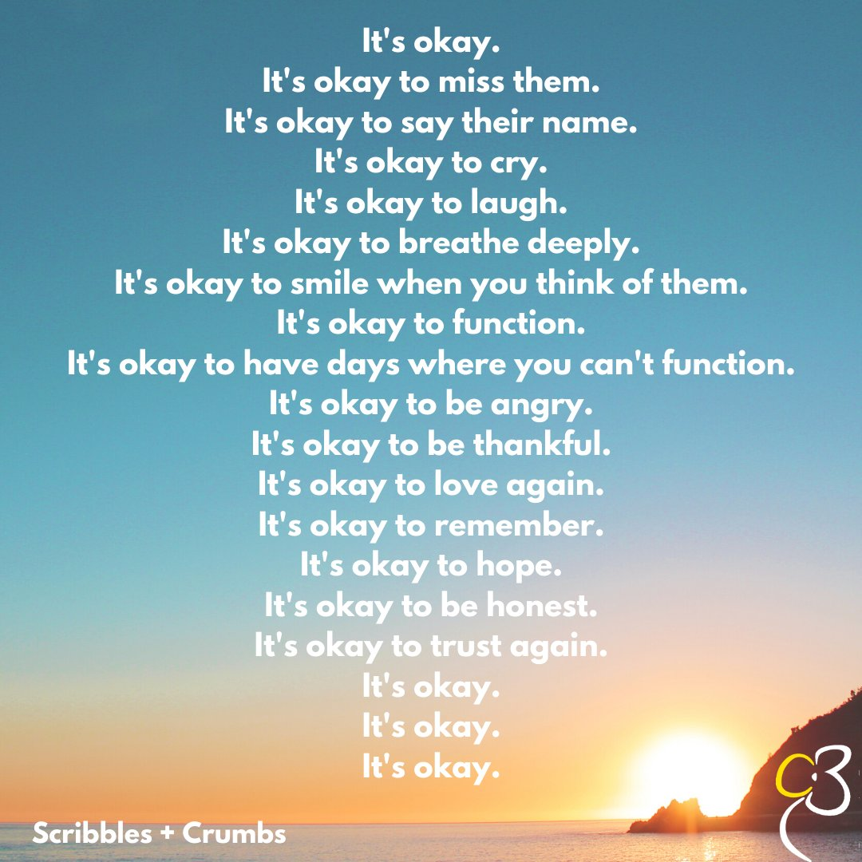

Resources to support the child with bereavement

How to make a memory jar

Children can sometimes find it difficult to talk about a brother or sister who has died. One way to encourage them to express how they feel is to create a memory jar. This simple activity helps children think about happy memories while creating something beautiful to help them remember their brother or sister.

The following instructions create a jar layered with different coloured salt and chalk to trigger different memories. You might prefer to mix the salt with powdered paint instead. You can choose to add objects to the jar that have significant meanings. The end result will be a way of remembering a special person and will allow children an opportunity to communicate their feelings.

**Let’s make it!**

* 1. Gather together a glass jar with a lid, a pen, salt, coloured chalks, felt tip pens and six sheets of A4 paper
* 2. Carefully fill the jar with salt and place to one side
* 3. On a piece of paper write down any five things you remember about the person who died
* 4. Draw a dot of colour next to each memory (for example, blue for their favourite song, pink for a time you did something fun together)
* 5. Spread out five sheets of paper and split the salt from the jar between them
* 6. Colour each pile of salt one of the colours of the dots by rubbing a piece
* 7. Carefully pour each pile of salt into the jar one at a time to create layers
* 8. Gently tap the jar to settle the salt then fill up any remaining space with plain salt to prevent the layers mixing
* 9. Put your jar somewhere you will see it often and keep your memory sheet safe so you can show it to friends and family.

How best to support me

These are helpful child centred templates to help a child think about how they can be best supported:

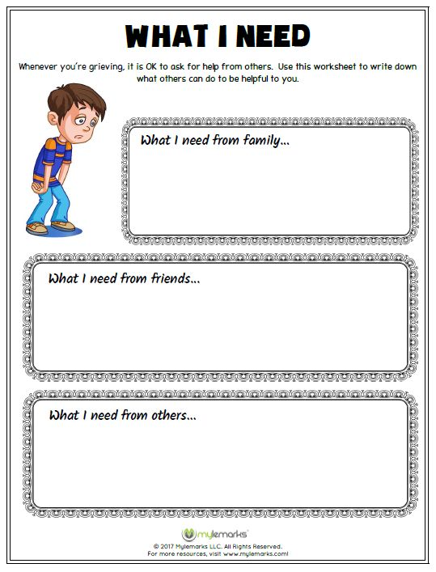

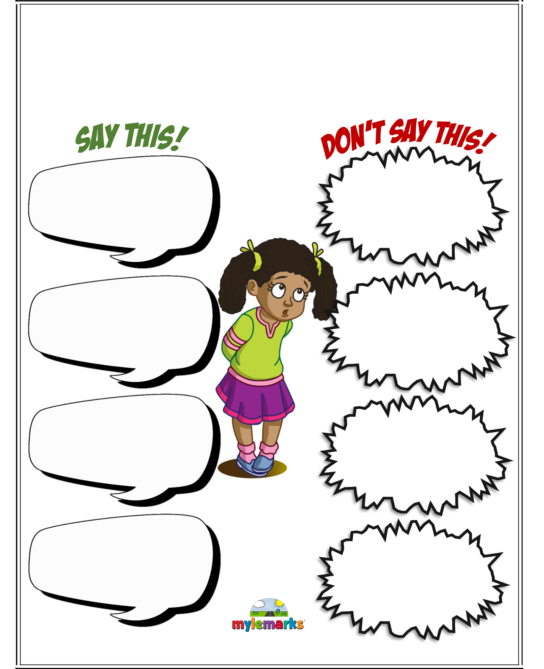

**SAY THIS!!!**

Whenever you feel sad, there are certain things that others can say to help you feel better. There are also things they could say to make things worse! When you get sad, what do you need to hear? What is it that you don’t want to hear?

Ways to support the grieving child

**Be patient.**

The child or young person will need time to adapt to what has happened. Spend time with them and listen to what they have to say when they are ready to talk. Respond to them and their unique situation.

**Assess their understanding.**

Assess your child’s understanding of the topic at hand; either what specifically happened to their loved one and/or their understanding of concepts like death. Many children have no prior experience with death and they may have no idea, or odd ideas, about what happens when a person dies. It’s good to assess the child’s understanding of what you plan to discuss with them because this will help you decide how to approach the subject. It can be helpful to begin your conversation by asking them about the thoughts and ideas already swirling around in their heads.

Such a conversation can take many forms. Some examples include:

If your family has recently experienced the death of someone very important, you may start with a specific question like – “Do you know why mummy is sad today?”

If you think the child already has some idea of what has happened (because children are far more tuned in than you think) you might ask something like, “What do you know about what’s been going on?” or “What do you think happened?”

If you’re discussing the loss of someone they didn’t know, you might show them a photograph and say something like, “Do you know who this is?” or “This is your brother, he died before you were born. Do you know what it means when someone dies?”

**Be honest and straightforward.**

Parents want to protect their children from pain and harm, this goes without saying. But sometimes this instinct can lead caring adults astray. Being honest with children about something as frightening and upsetting as death may feel callous and damaging, but it’s actually really important to be straightforward and truthful. Talk openly as this will reassure them that it is ok to talk about death. If you’re upset, don’t be afraid to show it. This can help the child or young person see that it’s ok for them to show how they're feeling.

Put yourself in their shoes. If you are curious, worried, or scared about something unknown, are you able to take your mind off of it? How do you feel when you can tell someone is withholding something from you, being evasive, or outright refusing to answer your questions? Do you stop wondering? I expect your answer to these questions is – “No!” You’d either worry, wonder, ruminate, or draw your own (potentially incorrect) conclusions. Don’t assume that when your child is put in this same position they won’t do the same.

As an adult caregiver, children look to you to clarify their understanding of what’s happened. Confusion and lack of information will only leave the child guessing. Although the simple truth may be heart-breaking, the fantasy of the unknown can be far more frightening to a child. What you say will depend on your situation, but generally speaking try to match the child’s developmental level. Don’t feel as though you have to tell them everything all at once and don’t give them more information than they can handle; hopefully, they will feel comfortable asking you questions now and in the future. With small children, phrases like the following may be appropriate.

“He is dead and will not be alive again.”

“Her body stopped working”

“He isn’t suffering and he can no longer feel anything”

“She took too much to a drug,” in the instance of overdose.

“Suicide is when someone makes their body stop working,” in the instance of suicide.

After explaining new concepts or providing them new information, assess their understanding of what you’ve said to them and invite questions.

**Help them understand and express feelings**

* Make time for grief and remembering the person who died. Consider setting aside time to talk either as a family or one on one with kids and teens about what’s coming up for them in their grief. Potential discussion starters include: How is your grief behaving today? What do you miss the most about them today?, What’s a funny/favourite memory you can think of?, What do you think they would be doing/ saying during this time?, How would things be different for us if they were here?, What’s helping you the most?, Where in your body do you feel your emotions?
* Validate their emotions: Remember that a wide range of emotions is normal in grief, so don’t be surprised if the child seems to show little emotion or if they show an emotion like anger, worry, or fear. Normalize and validate their emotions, whatever they may be.
* Reassure them that whatever they are feeling is ok.
* Help them to name and understand their feelings and explain that overwhelming emotions can come in waves.
* Reassure them that it’s ok to feel happy and remind them that it’s ok if there are times when they don’t think about the person who has died.
* If they are feeling angry, or experiencing similar emotions, help them find acceptable ways to express these feelings e.g. physical exercise, punching cushions or messy play.
* If a child or young person feels they are to blame for the death, e.g. because they’ve been naughty, or because they had thoughts about the person dying, you should help them to understand that it is not their fault.
* Address any fears they may have about being abandoned, or about other people dying.
* They may be concerned about what life will be like now, and what will happen to them. Try to make them feel secure and reassure them that they will still be loved and looked after.

**Help them understand the death**

* Use simple, clear language and words they will understand to help them make sense of what has happened. If appropriate, ask them questions to check they’ve understood.
* Answer the child or young person's questions honestly and simply. Some questions will be easy, and some will be more difficult. If you don’t know the answer, don’t be afraid to say so.
* Give concrete information.  For example, if they ask about the person’s body, it can be helpful to explain that when people die they don’t breathe, they don’t need to eat or drink, they can’t feel pain and they won’t ever be alive again.
* If they ask what happens to a person when they die, you could tell them that different people have different ideas about what happens, although nobody really knows for sure.

**Responding to questions**

* Don’t brush them aside. If they have been asked, they need an answer – even if it’s an honest, ‘I don’t know.’
* Use language the child can understand - Match your explanations to the developmental thinking and language skills of the child.
* Don’t use euphemism: People commonly use euphemism to replace words or phrases that make them uncomfortable. Many adults aren’t comfortable talking about death, even amongst other adults. This is likely why there are approximately 200 euphemism related to concepts around death and dying. But up until a certain age, kids are very concrete in their thinking. Thanks to their literal nature, euphemisms like the following only cause more confusion:
* “She’s in a better place” = She went somewhere great
* “She’s left us” = She left/abandoned us and she may or may not return
* “She’s sleeping” = She’s asleep and she will wake up.
* “She went to sleep forever” = There’s a chance that I could go to sleep and never wake up
* “She passed away” = Not sure what that means
* “She is resting in peace” = She’s sleeping somewhere peacefully
* You might feel tempted to use euphemism when explaining death to children, but don’t.
* Avoid being shocked by blunt enquiry - You may be asked some blunt questions about what happens to the body. This is not callous, but based on a need to understand. Sometimes the things they say will surprise you because their comments are astute and observant, cut right to the quick, or the words they choose are kind of silly. If a child says something that surprises you in the context of a conversation about death, try not to make them feel embarrassed, wrong, or ashamed.

Some examples of things that may take adults by surprise when speaking to a child about death include:

* + If the child has specific curiosities about the physical aspects of death
  + If the child seems like they don’t care
  + If the child’s response seems selfish or self-centred
  + If the child says something matter-of-fact or direct
  + If the child has existential questions or observations about the meaning of life and death
  + If the child makes angry, blaming statements
* Remember, there’s a wide range of normal responses and children will grieve little-by-little over time. Do your best to respond to their questions and comments in a calm, validating, and non-judgmental way.
* Be sensitive to differing spiritual beliefs and prepare them for customary rituals like funerals and memorial services. Talk to your child about funeral/memorial services before they attend them. There are three important things to cover in this conversation:
  + Include them in the planning to the extent possible. Ask them if there are things they would like to incorporate into the event or if there are special ways that they would like to honour their loved one.
  + Talk to them about what to expect before, during, and after the services, burial, etc. This may include discussions about things like the person’s body, burial, cremation, what types of emotions they may witness, what types of emotions they expect to feel, etc.
  + Discuss their concerns and worries. Are there any parts of these rituals that worry them? Brainstorm ways for them to cope in the moment. For example, a small child might like to bring a favourite stuffed animal to hold or might want to choose a trusted adult to be their buddy for the day. Older kids might want help identifying a room or place where they can go to take a break if necessary.

**Help them cope and adapt**

* Try to stick to their normal routine as much as possible.
* Children and young people may be comforted and soothed by:
  + having a cuddle
  + pets or soft toys
  + being read stories
  + [relaxation](http://www.handsonscotland.co.uk/relaxation/) or calming music
* School will play an important role in supporting the child or young person and they should be encouraged to speak to someone if they feel upset or alone at school. They should also be involved in deciding how to tell their peers about what has happened.
* If they have had time off school, it can be useful for a teacher to contact the family before they come back to school. They may find coming back to school difficult, so it can be helpful to talk to them about what support they might need.
* It can be helpful for them to meet other bereaved children and young people, as this can help them realise that they are not alone, and that other people have had similar experiences.

**Embrace diversions**

Remind children and teens that it’s okay to still have fun and take breaks — both from grief and concerns about the global health crisis. As a family, you can create a list of ways to have fun, including solo and group activities. Examples include board games, puzzles, watching silly movies and videos, scavenger hunts, dance parties, making playlists, or having a talent show. If you have access to technology, consider inviting friends and family to participate remotely in the talent show.

**What not to do**

* Don’t avoid talking about the death, even though this might be your natural reaction.
* Don’t worry that you might make things worse by talking about the death, you won’t.
* Don’t use ambiguous language that may confuse them e.g. “granddad has gone to sleep”.
* Don’t lead them to suppress their emotions by telling them to be "strong” or “brave".
* Don’t put pressure on them by saying they are now "in charge" or that they should "take care of their family”.
* Don’t react negatively to them if they behave in a way that you find inappropriate

**Activities**

The grieving process can be assisted by being able to do something. It can also help them identify other support people who they feel comfortable talking with.

Write a letter to the person you have lost telling them all the things you want to say to them

Write a letter to someone who is supporting you, so they know what you are going through. If you think it’s necessary, help them to decide what they will say and/or share if people ask them about their loved one’s death. Help them to find their own language and way of responding to the sympathies and/or questions of others. Reassure them that it’s okay to keep things private if they like.

Keep a diary or journal of how you feel.

Express yourself through paintings or pictures.

Write a song or poem.

Create a memory box full of pictures and items which remind you of good times you had with the person you have lost.

Send of a balloon or light a candle.

Make a scrapbook of photos and other keepsakes

* **Therapeutic stories**
  + Helps children understand difficulties/worries by creating a story about what might be happening
  + Uses metaphor to explore different solutions to difficulties
  + Central character faces similar difficult situation
  + Hope and possibility for child

**The Small Creature**

You can watch an example of a therapeutic story about loss called ‘The Small Creature’ by the British Hear Foundation, using the following link: <https://www.youtube.com/watch?v=Ks2DOoZtZ4A>

**References:**

National Alliance for Grieving Children (2020). *A Toolkit from the NAGC: Responding to Change and Loss.* Retrieved from [www.ChildrenGrieve.org](http://www.ChildrenGrieve.org)

The Therapist Aid (2014). *Goodbye Letter*. Retrieved from <https://www.therapistaid.com/therapy-worksheet/goodbye-letter/grief/none>

Youthlite (2020). *Activities for Grieving Children*. Retrieved from <https://youthlight.com/sample/activities_grieving_children.pdf>

Talking to your child about death

(particularly helpful for children with ASD and/or learning difficulties)

As with all children, those who are on the Autism Spectrum or with learning difficulties will be affected in some way by the death of a loved one. Although you might be inclined to shield them from conversations about death, it can be helpful to include them in these discussions. You will, however, need to account for their specific developmental, social and emotional learning needs.

Here are some suggestions for helping your child understand and process the death of a loved one.

**USE CLEAR LANGUAGE**

Your child may process information in a concrete manner. Try to avoid using words/phrases like “passed away” or “gone”, which may add to your child’s confusion. Instead use the actual words, such as “died”, which will provide clarity.

**PREPARE FOR NEXT STEPS**

If your child is attending the funeral or memorial service you can help to prepare for that in advance. Routine may be useful at this time. Using schedules or checklists of the day’s activities will be helpful in assisting the child to make sense of the event. You can also arrange for a trusted adult to be available for when your child needs some time away from others.

**PREPARE FOR A RANGE OF EMOTIONS**

Your child may experience difficulty reading the emotions of others. Let them know that people may be crying because they are feeling sad. Explain that they may be laughing or smiling when talking about the person who has died. You will need to prepare them for the range of feelings they may experience.

**PROVIDE STRUCTURE AND ROUTINE**

As far as possible, maintain your typical routines. These routines reduce anxiety for your child and support them in making sense of the atypical events. Routines can be comforting at a time of uncertainty.

**PREPARE FOR THE POSSIBILITY OF REGRESSION**

Know that at times of uncertainty and difficulty, all children may regress or turn to self-soothing behaviours.Provide opportunities for preferred activities, quiet time, or sensory-friendly activities that have proven successful in other areas of your child’s life.

**REMEMBER THE LOVED ONE**

Find meaningful and accessible ways to remember the person who died, e.g. if your child is drawn to wheels, remind him or her of a shared experience, such as when they played cars together.

You could share photos of your child and the loved one, or work together to create a memory book or box.

**MAKING A MEMORY BOX**

You can create a memory box to hold special things that remind your child of your loved one.

To make your box you need:

* An empty box with a lid. You can choose any sort of box that you like, as long as it has a lid that can be removed or flipped up to allow you easy access inside. Some people might like a bigger box. You can choose a wooden box or an already made paper mache box from a craft shop. You might also like a shoebox you already have in your home. Allow your child to choose a box that feels right to them.
* Glue, or a decoupage medium, or acrylic gel medium.
* Paint, marker pens, coloured paper – like construction paper, wrapping paper, tissue paper; photos or pictures cut from magazines or printed from the internet, words or letters you’ve cut out, fabric, ribbon, anything you like that can be smoothed, drawn, glued or painted onto a flat surface. You can use any combination of these kinds of things to decorate the outside and inside of the memory box.
* Different decorative items like buttons or beads, stickers, glitter, sequins, or anything you like that you can glue to the box. Make sure you don’t choose anything too heavy that might fall off.
* Optional: varnish, glue or shellac for making your box shiny and adding a nice finish when you have finished decorating it.

Remember, there is no one way to make a memory box. How your child decides to make and decorate their box is completely up to them.

When their box is finished, they can keep special things inside it that remind them of their loved one.

**SUPPORT YOUR CHILD**

Make use of support from other who already know your child. Make sure you inform others who care for your child about the death of the loved one so they can partner with you in supporting them.

Writing a social story about the loss of a loved one

One way to present information to your child is to share a social story with them. Writing a social story is fairly easy to do with the right information. Here are hints and tips for you to get started.

* Social stories are a way to develop your child’s understanding of situations that they find difficult (by helping to explain what happens and to help them to understand things from other peoples’ point of view).
* A way of communicating to your child what the expectations are (i.e. how to behave in social situations); not designed to change your child’s behaviour but to increase their understanding in the hope of encouraging appropriate responses to their environment (The Gray Center, 2011).
* An effective way of preparing your child for change, i.e. transition back into school.
* Helpful if your child finds change unsettling.

Often include pictures or photos to enhance their understanding.

**Tips for making up Social Stories**

* A social story describes very specifically **what** happens and **why**, and usually tells your child the desirable way to behave.
* It is written in consultation with your child and others who support her/him and after careful observation of the target situation, e.g. sharing toys with a sibling. Vocabulary (words used) and presentation of the story should be appropriate to your child’s age and ability.
* Usually written in the first person (i.e. name, me, I, my) and present tense.
* Can be personalised to include your child’s interests - should be attractive and interesting (i.e. include pictures of things that your child is interested in).
* Not a simple list of what to do - include sentences describing **where** a situation occurs, **who** is involved, **what** they are doing and **why.**
* Describes and explains the reactions and feelings of others.

Basic social stories use three types of sentence (according to Gray, 1994):

* **Descriptive** - what happens, where the situation occurs, who is involved, what they are doing and why
* **Perspective** - describing the reactions and responses of others in the target situation, sometimes the reasons for their responses, and may describe the feelings of others
* **Directive -** describe desired responses to social situations. They tell your child in positive terms what he or she should try to do or say in the target situation

Ratio – there should be 3-5 descriptive and/or perspective sentences to every directive sentence.

Words such as ‘**usually**’, ‘**sometimes**’ and ‘**probably**’are often used to help your child avoid over-literal interpretation and cope with changes - as children with social communication difficulties often interpret language literally, it is important to avoid statements that are inflexible. Preferable to use terms such as “I will try to…” rather than “I can…” or “I will..”, both of which require absolute compliance.

Stories are only as long as they need to be (keep to the point) - better to write separate stories for different issues than try to put too much into one.

Generally end with a positive affirmation - (e.g. I am a hard worker, I am a helpful person, I try my best); helps the child feel good about themselves while learning new behaviours.

Your child reads the story (or listens on audiotape) before the target situation arises, e.g. daily before/during breakfast, when they are relaxed and ready to receive the message.

Daily access to the story should continue as long as your child wants or needs - Use the story as often as necessary until the new behaviour becomes part of your child’s repertoire…..and hang on to it in case they need a future reminder.

Examples of social stories about the death of a loved one

**Social Story: Example One**

‘Once in a while, something different happens and the day doesn’t go the way I expect’

‘Today was one of those days. I learned something new. I learned that someone I love has died. I really wasn’t expecting that.’

‘Now I have a lot of questions. Some of my questions will have answer. But some will not.’

*“What does it mean when a person dies?”*

‘When someone dies, it means that their body stops working. Their heart stops beating. Their lungs stop breathing. When someone dies, they are not sleeping. They are not eating. They are not hearing. When someone dies, they never stop being dead.’

*“Why do people die?”*

‘People die for lots of different reasons. Most of the time when people die, they are old and have lived a long life. But not always. Sometimes people who are not old get very sick or hurt.’

‘Doctors can usually help people get better, but not always. Nobody can really answer why people die if they are young and haven’t lived a long life.’

*“Does it hurt to die?”*

‘Doctors try really hard to make sure that people who are dying are not in pain. They give them special medicine. Usually when doctors give people medicine, it helps them get better. When people are dying, medicine can’t make them better, but it can help to take away any pain.’

*“What happens to people when they die?”*

‘There isn’t a good answer. Since we can’t have conversations with people who have died, nobody really knows what happens. Different people believe different things, but nobody knows for sure.’

*“But what about the person’s body?”*

‘Different families have different traditions. Sometimes the person’s body goes into a box called a coffin. The coffin is placed in the ground. That’s called a grave. Sometimes the person’s body is cremated, which means it is turned into ash. It doesn’t hurt to be buried or cremated because the person is not alive anymore.’

‘Many people have a ceremony to remember the person who died. It’s called a funeral or a memorial service.’

*“When someone dies, what does it feel like for the people who are still alive?”*

‘When someone dies, people may feel very sad. They are sad because they miss the person who died. They may wish that they could see them again.’

‘I see some people crying, so I know they are sad. I feel like crying, too. It’s okay to cry when I feel sad.’

‘I see some people laughing when they remember funny stories about the person who has died. I sometimes feel like laughing too. It’s okay to laugh when I remember funny stories about the person who has died. When I laugh, I feel less sad.’

‘I find out that sometimes there are a lot of people around after someone has died. It can feel noisy, and people might try to hug me a lot. I know it’s okay for me to take a break, or go to a quiet space and come back when I feel ready.’

*“What can I do when someone I love has died?”*

‘When someone I know has died, I can think about their life and what we liked to do together. I can talk about that person, how nice they were, and why I loved being with them. Sometimes looking at pictures and thinking about them might make me feel sad, sometimes happy, and sometimes both.’

*“When someone I love has died, will I ever see them again?”*

‘When someone I love has died, I will not see them anymore. I will always love them, though. I might think about them when I do something that they liked to do. That’s a good way to remember someone who has died.’

‘It’s okay if I want to talk about the person who has dies. It is okay if I don’t.’

‘Even when someone dies, I will have regular days again. I will still wake up, eat my breakfast, and go to school or stay at home. Sometimes I might think about the person who has died. I might think of more questions to ask. Now I know that a lot of my questions will have answers, but some of them won’t.’

‘Most days are regular days. Most days I know just what to expect. Today was not a regular day, but I learned a lot. Mostly I learned that asking questions really helps!’

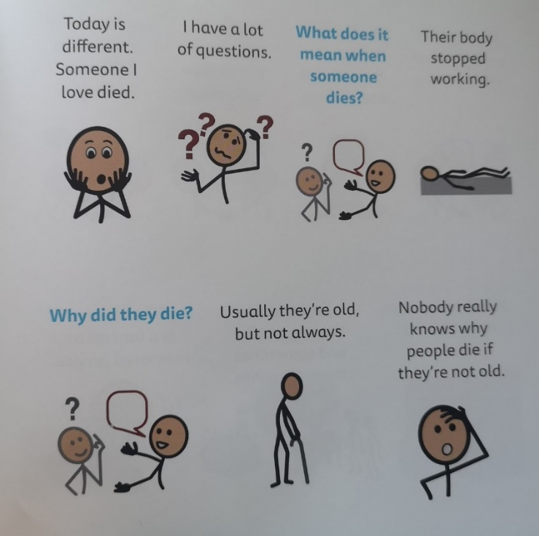**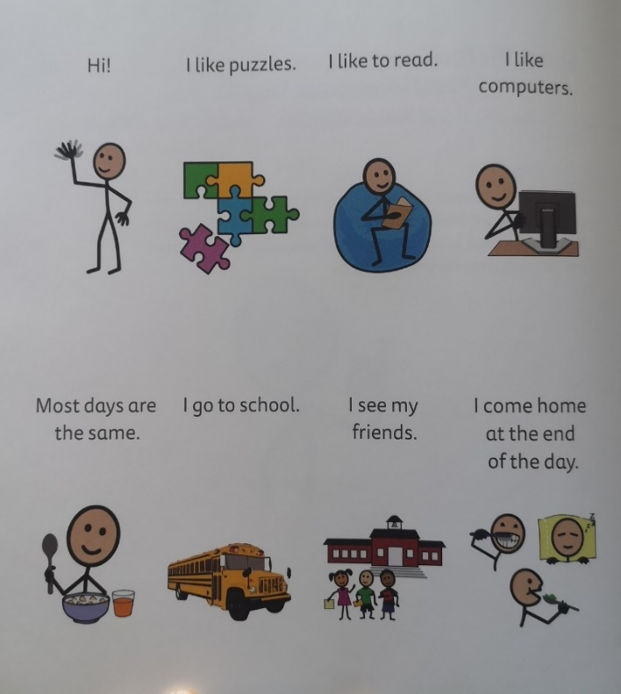Social Story: Example Two**

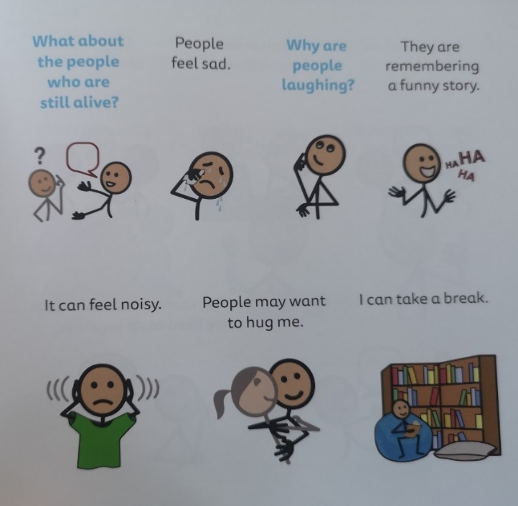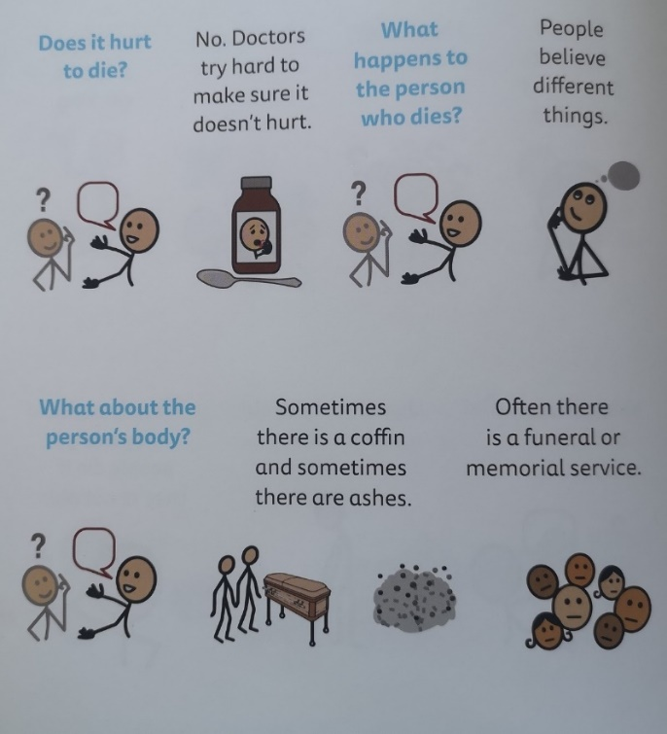

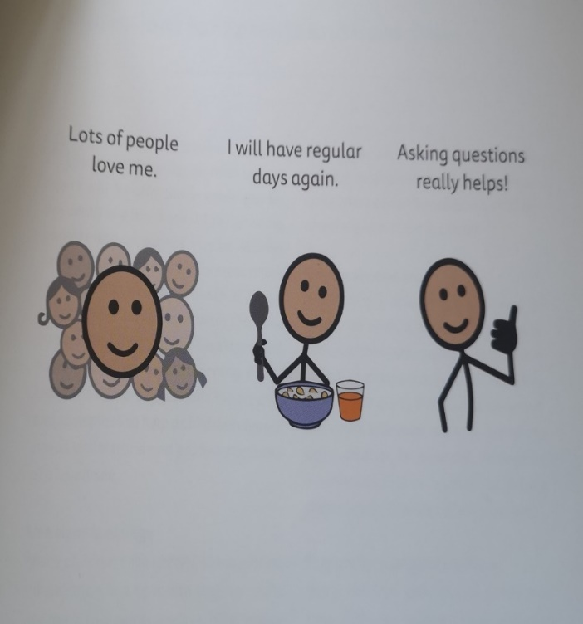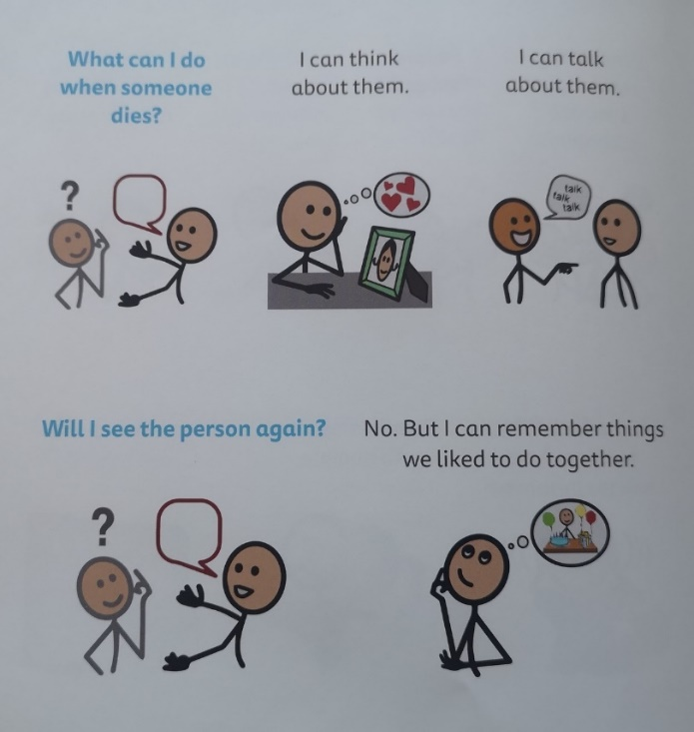

**Social Story: Example Three**

My parents told me that my grandfather died. This is very sad because he was so special to me. It is sad to lose someone you love.



I have a lot of great memories of my grandfather. I will always remember celebrating special events with him and enjoying fun times with him. Thinking of all of my great memories is a very good thing.



I will miss my grandfather a lot. I might feel like crying. That is OK. Tears let out my sad feelings. It is OK if I need to cry.



When I think about my grandfather, I might get very upset. That is OK. If I get upset, I can talk to my family or my teachers.



My family may also cry because they will miss my grandfather too. That is OK. Everyone might need lots of hugs.



I won’t be able to see my grandfather anymore. I can think of him.



When people pass away, there may be a memorial or a funeral. Memorials and funerals are special times for the family to remember loved ones who have died.



There will be a memorial service for my grandfather. The memorial service will be held at a church or a crematorium.



There may be a lot of people at the memorial service. They may tell my family that they are sorry and give my family hugs. I may see my family cry. This is OK. I can cry too.



People may talk about the wonderful memories of my grandfather. They may say prayers too. I can think about all of the wonderful memories of my grandfather.



At the memorial service, everyone will be talking in a quiet voice. A lot of people will be whispering. I need to remember to speak quietly too.



After the memorial service, I may go out to lunch or dinner with my family. We will try to smile and remember the great times with my grandfather.



Look after yourself. Prepare to self care

Self-care is key to calming ourselves so we have the resources (brain power!) to care and support others. We would recommend trying to implement structure, routine, and consistency to your life as well as those you care for! For self-care to be effective it needs to be sustainable and practical for your lifestyle!

Suggestions to self-care:

MINDFULNESS

The three main principles of mindfulness are:

- Being in the present moment i.e. focus on the right here, right now and not the future or past!

- Noticing and increasing our awareness of what is going on

- Placing no judgment on our experience, i.e. no labelling of things we notice as good nor bad, right or wrong, they just are!

There are lots of Mindfulness apps that you can access. Mindfulness practice does not have to take long, you can do it anywhere at any time for however long (even 30 seconds!)

BREATHE

We hear it all the time! But it’s true, slowing down your breathing can really help ground you and slow things down. Try imagining blowing up a balloon in your stomach and slowly releasing it.

BE YOUR OWN BEST FRIEND

If your best friend came to you upset and struggling what would you say to them? Write this down... pin it in a place you regularly look. This is how you will speak to yourself when you are struggling. Give yourself a break, be kind, you’re doing your best in a difficult time. Go you!

DOING SOMETHING MEANINGFUL TO YOU!

Think of an activity you enjoy. It can be ANYTHING! What is it about the activity that you value? For example, if you enjoy going out for a coffee with your friends, you may value connection with others. Although you may not be able to go for a coffee with a friend could you be creative about how you could still live your life by this value in a different way. For example, Skype your friend and sit and drink coffee together in a designated area of the house.

Try to identify what you value about the activities you enjoy doing in your life and think about how you can still live your life by these!

**Remember**, It’s OK for you and your child to feel sad, angry, confused, empty, guilty, anxious, and many other emotions – and it is OK if you don’t!

Help the child to say goodbye

It is very hard to say goodbye to someone we care about. This section includes resources for families and children/young people to help cope with these circumstance it a more positive way. There is information on supporting children through the funeral as well as ways to say goodbye if they are unable to attend. The resources help children/young people cope with the death of their loved ones and find healthy ways to remember that special someone.

**How can I prepare a child for the funeral?**

You can best prepare children for the event by letting them know in as much detail as possible about what they will experience. Explaining the service in age appropriate terms can help alleviate some of the anxiety that comes from not knowing what to expect. Provide as many details as you can about what they will see, hear, smell and even feel at the service. Tell them about any rules that they will have to follow, such as needing to be quiet at certain points during the event. As with any other aspect of funerals and death, concrete descriptions of what will happen rather than euphemisms are the most helpful:

*“A funeral is when family and friends come together to share feelings for the person who died such as thank-you, I love you, and goodbye. We remember the life of the person who died and share stories, laughter and tears. We receive comfort and support by being with the people who care about us.”*

You can explain to the child that there may be music, people may tell stories and there may be times of silence. Prepare children to see others expressing their feelings, such as crying and laughing.

*“You may see many people showing a lot of different feelings. They may be laughing, they may be crying and any and all of those feelings are okay. Adults cry too and that’s healthy. It can help to let our feelings out. But it’s also okay if you don’t cry. People show their feelings in different ways.”*

*Let children know that they may feel a wide range of feelings as well.*

*“You may feel many different feelings at the same time. This can be confusing. And sometimes when we have a lot of different feelings at the same time the feelings can come out as a big “giggle burst”.*

Also let kids know that sometimes during the funeral we may not feel anything at all, and that’s okay. Sometimes our feelings come weeks or months later.

Many children are confused by the common saying of “I’m sorry” or “I’m sorry for your loss” which they are likely to hear both directly to them and indirectly to others in the days and weeks following a death. Some children confuse this with an apology and wonder “Did all these people cause the death in some way?” or “Why is that person apologizing when he didn’t do anything to cause the death?”

Others simply feel unsure of how to respond. Prepare kids for the fact that they are likely to hear this from people not only at the ceremonies around the death, but also in their day-to-day life as well. Let them know it is a common saying when someone dies, and it doesn’t mean that the person is apologizing for doing something wrong. Provide them with language they can use to respond which can be as simple as “Thank you” so they are not left trying to figure out what to say in the moment.

Children thrive on knowing what to expect. They need to know WHO will be there, WHAT will happen, WHERE the service will take place and WHEN and WHY it’s happening.

Children are naturally curious about what happens to a body after death. Begin this part of the conversation by making sure the child understands that the body of the person who died does not work anymore and will never work again.

*“Grandpa’s body has died which means it has stopped working and will never work again. When a body dies it doesn’t feel anything anymore. So grandpa’s body does not feel pain, cold, heat, hunger, etc.”*

Also, when talking about “the body” with a child, always explain that the body has a head. Sometimes when we use the word “body”, children interpret it as being the area from the neck down and believe that the body that is being talked about does not have a head.

Once the child understands that the body (including head) is no longer working at all, let them know how the body will be involved in the event. For example:

*“We put grandpa’s body in a special box called a casket. You will see the casket at his funeral. People will carry it in and out of his funeral.”*

**What if children/young people and families are unable to attend the Funeral?**

During these unprecedented times it is still unclear whether family members will be able to attend funeral of loved ones. The Government initial advice has been for funeral directors to restrict attendees to immediate close family only and respect social distancing guidelines. This is going to be a very difficult time for families and loved ones and impact on their abilities to say goodbye.



If you could bring something to the funeral for your special person, what would it be and why?

Draw or write your ideas.

A memory table can be a beautiful thing at a funeral service.

If you can’t be at the funeral, this is still a good idea to do at home.

What would you put on your special someone’s memory table?

Draw or write your thoughts.



Draw a picture or write a letter to the special person who has died.

Show/explain what you will always remember about them.

[](https://www.google.co.uk/url?sa=i&url=http%3A%2F%2Fclipart-library.com%2Fclip-art%2F361-3610838_mq-red-hearts-frame-frames-border-borders-rectangle.htm&psig=AOvVaw0Ioq8i7qiW8Cc3ICl0QeYu&ust=1585407859830000&source=images&cd=vfe&ved=0CAIQjRxqFwoTCICM0dT2uugCFQAAAAAdAAAAABAL)

It is good to   
remember special  
people after   
they have died.

Remembering is a   
way to honor your  
special person. It  
will make you feel  
closer to them. This   
is very important   
when you are grieving.

Draw or write  
about a special time  
you has with your   
special someone.

Ways to say goodbye/Remember special people:

* Feelings Book - As time goes on and you wish to share your feelings, you can make a ‘feelings book’. Include some things that make you feel safe and loved. Put the date on each page to show how your feelings change as time goes on.
* Memory Book – you may wish to make a memory book with help from your family. Pages may include: “My most special Memory,” “A letter to my special person on their birthday,” or “A sad day is when I miss my special person.”
* Keep something that belonged to your special person so you can touch and look at it and remember them.
* Memory Box – you could put photos and objects from your special someone in this box and look at it anytime you’d like. Think about what you might like to collect and put in your memory box.
* If you can’t be there to say goodbye on the day of the funeral, as a family you may wish to realise Balloons with messages on. This could be your own personal way to say goodbye to your special someone.

Resources adapted from

* <https://www.griefhealing.com/column-explaining-the-funeral-to-your-children.htm>
* Janis Silverman – Help me say Goodbye
* Michelle Methven & Andrea Warnick - PREPARING CHILDREN FOR FUNERALS AND MEMORIALS

COVID 19: Funerals and memorials

In normal times funerals serve a number of important purposes after someone dies.

* They can help to make the death seem real.
* They offer people a chance to share thoughts and feelings about the person who has died, and to say goodbye.
* They bring families and friends together to support one another.
* They give people a focus at a time when so many things seem out of a person’s control.

All of these functions may be disrupted if the funeral is delayed, shortened and if friends and family, even close relatives, cannot attend.

**How you can help yourself**

If you cannot attend a funeral, it may be possible to still feel part of the event to an extent. It may be possible for a friend, relative or someone from the funeral directors to record, video, or even live stream the event. You may be able to write or record a message to be read out or played at the funeral. Contact your funeral director for advice.

If you cannot watch the funeral, you could set aside the time while the funeral is taking place (or later) to hold your own act of memorial at home. You could: look at pictures, play some of the person’s favourite music, write a message to them, light a candle or follow any of your own cultural rituals.

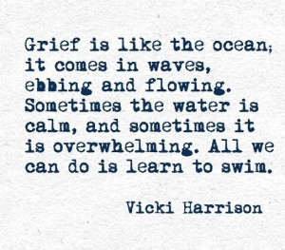Ask those who have been able to attend to call you afterwards so you can hear their account of the event, and take the time to share your memories of the person.

If the funeral is delayed or reduced to a very short service you could still set some time aside to have your own private goodbye including any of the ideas above.

We will not be under these restrictions forever, and at some future point you may be able to hold a formal or informal memorial to those who have died.

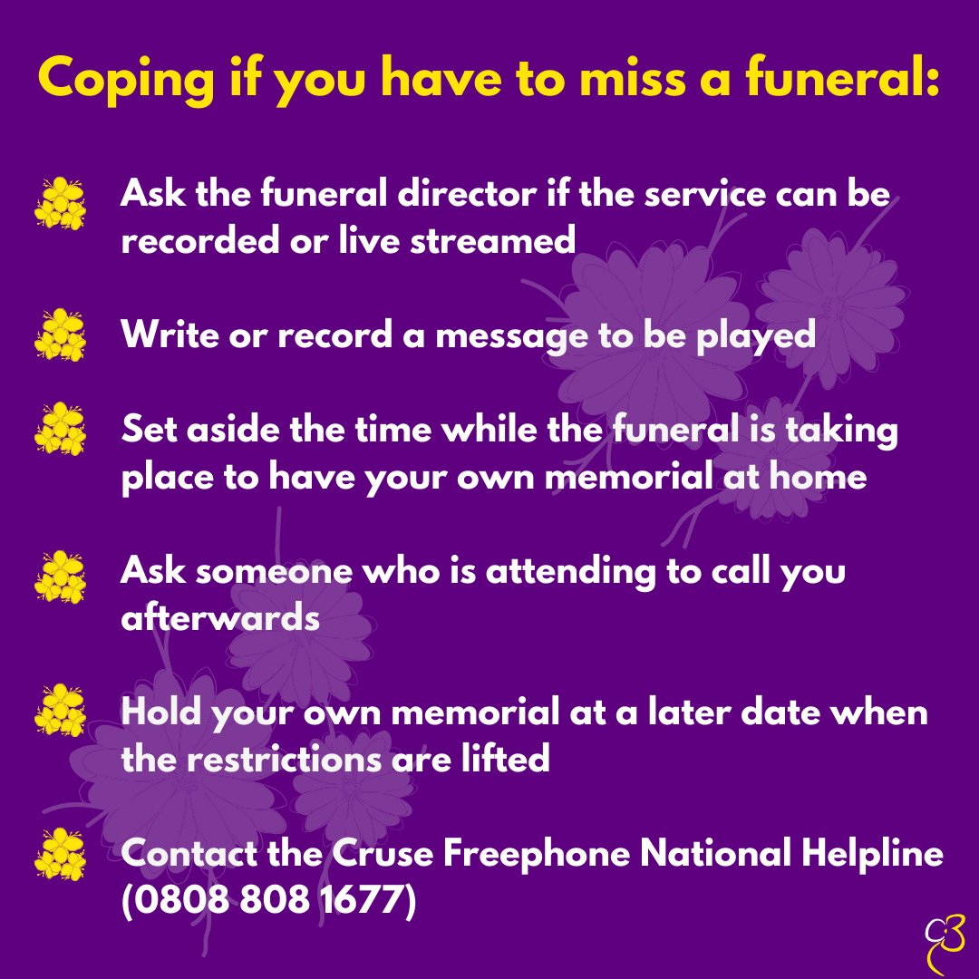



Coronavirus: grieving and isolation

**How you can help yourself**

Although you may not be able to see people in person, you can **keep in regular contact with others**using the phone, text, or internet if it is available to you.

**Look after yourself and get rest.** Try to get some fresh air or sunlight each day - even opening a window can help. You may find it helps to do some exercise around the house if you are able. Try to keep to a regular routine of getting, up and dressed and eating meals at the usual time, whether you are on your own or part of a family group.

At times when you have more energy, you might want to find some jobs to do around the house or garden (if you have one). It is normal to move between intense grieving and looking to the future after someone dies, and there may be some things you can achieve even if you cannot go out.

**Don’t feel guilty if you are struggling**. Reach out to others who might be finding it difficult too, you may be able to help each other. **Seek practical help from friends, family or neighbours**.

You can also contact the Cruse Freephone National Helpline on 0808 808 167

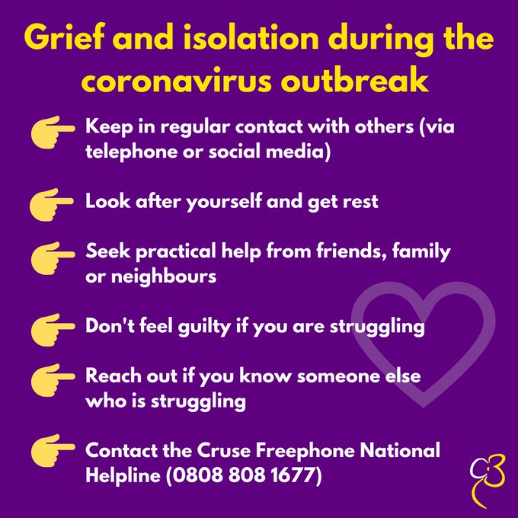

<https://www.cruse.org.uk/get-help/traumatic-bereavement/coping-with-a-crisis>

Sharing Information on the Death of a Member of the School Community

***Checklist for school staff in event of a death linked to COVID-19***

Due to social distancing requirements linked to the outbreak of COVID-19, certain steps that would ordinarily be taken in the event of a death of a member of the school community may not be possible (e.g., holding memorials at school or making arrangements for non-family members to attend the funeral). However, below are some key points that should be considered in the event of a death of a member of staff or a child linked to COVID-19.

|  |  |
| --- | --- |
| Checklist for Schools | |
| Gather factual information about what has happened |  |
| Identify senior member of staff to take lead on sharing news of the death |  |
| Have a script for person(s) who may take phone calls/emails relating to the death |  |
| Keep a record of all incoming and outgoing calls/advice, and names of contact people |  |
| Ensure all staff are briefed as soon as possible. This will need to be a priority given that many staff will be away from the school self-isolating/social distancing. |  |
| Inform Chair of Governors and ask him/her to cascade news to other governors |  |
| Ensure Local Authority are aware of the death |  |
| Inform parents/carers and advise them on how to listen to and support their children. Draft letter – keep it brief, factual and include acknowledgment of the family’s grief |  |
| Be aware of staff and pupils who will be affected most (e.g. staff who have recently experienced a bereavement) |  |
| Arrange to hold memorial/assembly once school has re-opened |  |

***Breaking the news to children of different age groups***

Here is some advice for parents/carers relating to how they might break news of the death to their children and how they might support them in coming to terms with the death in the days that follow:

**Early Years/Lower Primary**

* Read a story about bereavement
* Model your emotions e.g. 'I feel very sad', 'I feel angry'
* Explain they might feel e.g. 'You might feel cross, sad, confused, nothing at all'
* Be very clear in your language use e.g. explaining that this means the person can't come back, even though they would like to

**Upper Primary**

* Model and acknowledge your own emotions, encourage pupils to talk about their own emotions (including anger)
* Continue to encourage children to grieve/talk about the dead person after breaking the news

**Secondary**

* Try to address rumours as quickly as possible
* Consider discussing social media e.g. what is/isn't acceptable to discuss
* Discuss helpful coping mechanisms (e.g. talking to a trusted person, talking to friends, memorial activities)
* Encourage non-verbal outlets for expressing emotions e.g. drawing
* Revisit the topic of grief again at a later date, encouraging open, respectful discussions about philosophies around death/dying/religion

**Post-16**

* Provide signposting information for help-seeking e.g., websites for coping with grief
* Offer time for discussions
* Consider what they may have already heard/read e.g. in the press, on social media

**General Tips for All Age Ranges:**

* Tell children as soon as possible
* Encourage questions
* Use words such as ‘death’ and ‘dead’. Avoid ambiguous language e.g. passed away, gone to sleep, having ‘lost’ someone. If you refer to ‘heaven’, the child may think this is a place that someone could come back from
* Give as much truth as possible to children (in negotiation with the affected family/school)
* Let children know it is ok to show their emotions
* Try to maintain your usual routine in so far as is possible

***Template Scripts for Breaking the News***

A template is provided below, with thanks to Winston’s Wish and the National Educational Psychological Service (NEPS). Before using this script, please ensure you establish exactly what information can and cannot be shared with pupils/students, as in the majority of cases, the names and hospital locations of injured people would not usually be released.

*I’ve got some really sad news to tell you today that might upset you. I know you will have heard of covid-19/coronavirus, and know that sometimes people who catch it get better, but other times people die from it. Mrs X/Pupil Y has been ill with covid-19/coronavirus. I have to tell you that Mrs X/Pupil Y died yesterday in hospital.*

***Additional Information for Schools to Share with Parents/Carers***

**Information for Parents/Carers**

It is normal for children to deal with “bad news” in different ways. It is very difficult to predict how any individual child will respond. Some children may be immediately sad or angry while for others, they will have no obvious response until something occurs that makes the loss ‘real’ or personally meaningful.

**When children are stressed or worried, it is normal for them to show some of these signs. They may be:**

* More clingy, anxious, emotional
* More difficult to put to bed, have difficulty going to sleep or staying asleep or have nightmares
* Needing to go to the toilet more often than usual
* Showing loss of recently acquired skills (e.g., wetting the bed, being more accident prone/clumsy or forgetful)
* Finding routine skills more challenging
* Wanting to talk about what happened, or not wanting to talk
* Re-enacting a feature of the event through repetitive play / ask the same questions
* More likely to make “silly” mistakes, have difficulty concentrating or struggle to remember things
* More irritable or short tempered
* Experiencing physical symptoms (e.g., feeling sick / headaches)
* Showing a reduced sense of humour or be more ‘moody’ than normal

**These are some ways in which you may help your child:**

* Provide more reassurance than usual
* Stick to routines as far as possible
* Be understanding and accept your child’s reactions to the circumstances
* Be available by providing time and support for your child to acknowledge his/her feelings
* Sensitively maintain the usual boundaries and expectations of behaviour
* Try to be consistent, clear and patient in what you say
* Acknowledge that the event was distressing but balance with re-assurance that the world is usually reliable, predictable and dependable.
* Make allowances for your child (and yourself)
* Listen to what your child is saying rather than what you think they might be saying. Don’t deny or contradict your child’s perceptions but appropriately challenge rumours or speculation.
* Be prepared to answer the same questions over and over, this can be your child’s way of making sense of the situation.

**Most children cope well with bad news when they are given the kind of support suggested here. However, if you have continuing concerns about your child, please seek advice from the school.**

Template Letter: Informing parents/carers of the death of a pupil

Dear parent/carer

I am very sorry to have to tell you that one of our pupils in year X, (name), has died as a result of the coronavirus.

(Name) was (insert description, e.g. caring, funny, etc.) who loved (insert hobbies/interests) and was a cherished member of our school. We are deeply saddened by (Name’s) death and he/she will be greatly missed.

We have been in touch with (Name’s) parents who wanted his/her friends to know what has happened.

When someone dies, people often experience a number of mixed emotions, including sadness, anger, confusion, anxiety and fear. Information provided by NPT Educational Psychology Service and School Based Counselling Service is provided with this letter to help you talk to your children about what has happened and to help them deal with difficult emotions.

(Name’s) life will be celebrated in a special (assembly/service) that will be held for children and staff when school reopens.

Our thoughts are with (Name’s) family.

Yours sincerely

Head Teacher

Template Letter: Informing parents/carers of the death of a member of school staff

Dear parent/carer

I am very sorry to have to tell you that (Name), who has been a (teacher/teaching assistant/other member of staff) at our school for (X years), has died as a result of the coronavirus.

We are deeply saddened by (Name’s) death. (Name) was a valued member of our school and he/she will be greatly missed.

When someone dies, people often experience a number of mixed emotions, including sadness, anger, confusion, anxiety and fear. Information provided by NPT Educational Psychology Service and School Based Counselling Service is provided with this letter to help you talk to your children about what has happened and to help them deal with difficult emotions.

(Name’s) life and contribution to the school will be celebrated in a special (assembly/service) that will be held for children and staff when school reopens.

Our thoughts are with (Name’s) family.

Yours sincerely

Head Teacher

How to support your child through Bereavement- Advice for parents

We all find it difficult to cope when someone we love dies. Helping a child to cope with the loss of someone they love is particularly difficult when you are coping with your own grief. But there are things that you can do to support them through this difficult time.

**How do children grieve?**

Just like adults children go through a grief process and there is no rulebook for how a child might grieve or how you can best support them. Sometimes they may be very sad and upset, sometimes they will be angry and pose challenges with their behaviour, whilst at other times they will seem to have forgotten all about it. But they will not have forgotten. They will still want and need to talk, share memories and explore their feelings.

**Should my child attend a funeral?**

Funerals offer an important part of closure when we have lost someone we love. It is also an important way of celebrating the life of a loved one.

The circumstances around the COVID 19 crisis has made attending funerals especially difficult. If the person has died due to COVID -19, it is likely that all procedures around the funeral home and funeral itself will be tightly restricted. In these circumstances there will likely be no choices around children’s participation and the whole procedure may seem impersonal and clinical.

**Alternative ways for a child/young person to ‘say goodbye’ to a loved one who has died?**

If the child or young person is not able to attend the funeral, there are several ways to make saying goodbye special and meaningful. It will be important to explain to the child/young person the reason why he/she cannot attend the funeral e.g., ‘*to keep people safe and stop the virus spreading we will not be able to attend the funeral*.’ Offer them alternative ways of celebrating that person’s life. Some examples may include the following:

* Children/young people could participate by contributing to some of the choices within the ceremony, e.g., choosing flowers, choosing music or poems, making cards/pictures to be placed on the coffin or writing memories/stories/tributes to be read at the funeral/placed in the coffin.
* Create an alternative celebration of life at home: sharing stories about the loved one, listening to their favourite music, perhaps planting flowers in their memory, making a memory box or making special keepsakes.
* Agree on special traditions for remembering the lost loved one. This may be creating a memory book, looking at photographs, lighting a candle on birthdays, anniversaries, Christmas. These special things can form part of family routines.

**What can I do to support my child?**

**Reassure them that it is not their fault**

When someone dies children can blame themselves, particularly if the death is sudden. It is important to reassure them that nothing they have said or done has made this happen and they couldn’t have done anything to change it.

**Let them know that it is okay to have fun**

Let your child know that it is okay to have fun. Children often make sense of things through play. Playing is therapeutic as it gives them a break from grieving and a chance to express their feelings in their own way. It can also help them to relieve their stress and anxiety.

**Understand that they haven’t forgotten about it**

Sometimes children find it difficult to fully acknowledge or talk about the

person who has died. This does not mean they do not care- it is normally because children cannot deal with strong emotions for long periods of time. It is almost as though they have an automatic ‘shut off’ that kicks in when they cannot cope any longer.

**Let them share feelings and fears**

Give your child plenty of opportunities to express their feelings, for example, through play, talking and sharing memories, drawing/painting, even reading age appropriate books about loss (see resources)

**Show them that it is okay to be upset**

Children model their behaviour on how those around them are behaving. If you hide your own grief from they may feel that they also need to ‘be strong.’ Children need to see grief and know that it is okay

to cry/be sad or angry. The more you can talk with them about what has happened the more they will feel able to talk to you.

**Create stability**

When a close member of the family dies, especially

one who has been involved in the care of a child, children can

become worried about remaining carers leaving them too. Children’s routines often change as a result of loss and they can become more clingy than usual. Children need to know who will be caring for them and also to know that lots of things will stay the same-e.g., their weekly football training etc. Creating a sense of normality is key. You can help them by letting them know

what will be happening in a clear way.

**Be ready for their grief to**

**re-surface at key times**

It is not usual for children to re-visit their grief at key times such as starting school transition, approaching significant changes in their lives or birthday/anniversaries/

Christmas. If a special day/event is coming up, talk to them in advance about what they would like to do and acknowledge that you know it is difficult for them.

**Let your child take the time they need to grieve.**

There are no rules for children or adults about how long is ‘normal’ to grieve. Everyone is different. Some children may adapt more quickly to the loss of someone they used to see frequently as the change to the routine will make it clear that the person is not coming back. They may take longer to accept the loss of someone the saw less frequently because a lot of the time, things may seem the same. This may be especially true in the social distancing circumstances surrounding the COVID 19 outbreak. In these cases children may ask when the person is coming back. As it difficult as it may be, retelling the story may be an important way of helping children to process what has happened.

Like many adults, children can also experience periods of low mood, becoming withdrawn or seeming disinterested in things they enjoy. This can be a normal part of grieving. However, if this appears to continue for a long time, or you are worried, speak to your GP for advice and support.

**How to TAKE CARE of Yourself: For parents**

The death of someone close to you can be very overwhelming do you will likely feel a mixture of emotions. There are some things you can do that may help you to cope and there are people who can support if you need it. There is also a list of useful resources and support services at the end of this document

**Remember:** Looking after your own mental health at this time will be crucial in helping you to support your children. Making time for your own grief process is important to supporting the grief process of others.

|  |  |
| --- | --- |
| **BE KIND TO YOURSELF**: | Grief is painful. Whilst self-compassion is not the cultural norm it should be. Treat yourself as you would treat a beloved friend, in word, thought and deed. Give yourself space to feel the pain of grief and also give yourself permission to take ‘timeout’ when you need it. |
| **GET ENOUGH REST:** | Practice good sleep hygiene. Insomnia and excess sleeping are common during this time. Setting regular bedtime and wake times may be helpful. Meditation/sleep stories can help with insomnia and inducing rest. |
| **BREATHE MINDFULLY:** | Breathing fully with intention accomplishes two things: 1) It turns off the stress response known as ‘flight or flight’  2) It helps you to focus on the present moment which can stimulate mental wellbeing. |
| **MOVE:** | Physical movement can help your body release tension associated with grief- a short walk among nature yoga or cardiovascular exercise will contribute to better sleep and improved wellbeing |
| **EAT HEALTHILY:** | Food can have a big impact on how you feel emotionally. Nutritious food can also protect your ability to stay physically well, which is often compromised by the high stress that comes with loss. Drinking plenty of water will help your physical and mental state. Alcohol should be limited as it can depress your mood and sleep schedule. |
| **CONNECT WITH OTHERS/SEEK SUPPORT:** | ‘Social distancing’ may make it difficult to connect with family and friends during the COVID 19 outbreak. However, there are still many ways that you can reach out to people and nurture relationships with other family members and friends- through phone calls or online video calling. There are also helping line services available when things get tough (see resources) |

Book and Links to support bereaved children, young people and families

* Winstons Wish the charity is fantastic both online and when called and will send out information after the death.

<https://www.winstonswish.org/supporting-you/supporting-a-bereaved-child/>

* The childhood bereavement network

<http://www.childhoodbereavementnetwork.org.uk/>

* Cruse Bereavement Care, Coronavirus: dealing with bereavement and grief

<https://www.cruse.org.uk/get-help/coronavirus-dealing-bereavement-and-grief>

* Grief Encounter Website

<https://www.griefencounter.org.uk/>

* hopeagain.org.uk – A website specifically for bereaved children and young people
* YouTube clip on badgers parting gift

<https://www.bing.com/videos/search?q=badger%27s+parting+gifts+youtube&docid=608027996982346679&mid=647B4E834FA8D323AA79647B4E834FA8D323AA79&view=detail&FORM=VIRE>

* <https://www.sueryder.org/supporting-a-child-through-bereavement>
* <https://www.childbereavementuk.org/coronavirus-covid-19-information>
* NHS Website

<https://www.nhs.uk/conditions/stress-anxiety-depression/children-and-bereavement/>

**Books to support children, young people and families with bereavement:**

* Book for supporting a child when the parent is seriously ill- it is £7.50

<https://shop.winstonswish.org/products/as-big-as-it-gets>

* Muddles, Puddles and Sunshine: Your activity book to help when someone has died. Designed to help younger children to cope with the death of someone close to them.
* The Memory Tree by Britta Techentrup.
* <https://www.mariecurie.org.uk/help/support/bereaved-family-friends/supporting-grieving-child/books-about-death#booksforchildren>
* <https://www.mariecurie.org.uk/help/support/bereaved-family-friends/supporting-grieving-child/books-about-death#booksforadults>
* <https://www.funeralguide.co.uk/blog/bereavement-books-younger-children>

**Age 5 and Under**

**Goodbye Mousie** By Robin H. Harris and illustrated by Jan Ormerod, Reprinted edition 2004 Aladdin Paperbacks.

**I Miss You (A first look a death)** By Pat Thomas and illustrated by Leslie Harker 2001, Barron’s Educational Series

**Ages 5-8**

**A Birthday Present for Daniel: A Child Story of Loss,** By Juliet Rothman and illustrated by Louise Gish 2001, Prometheus Books

**Ages 9-12**

**Michael Rosen’s Sad Book** by Michael Rosen and illustrated by Quentin Blake, 2004, Walker books. The book helps to normalise feelings of sadness and can be useful as a trigger to help difficult conversations.

**Ages 13-16**

**Straight Talk about Death for Teenagers: How to cope with the loss of someone you love** by Earl E.Grollman, 1999, Sagebrush Ed Resources

* *Missing Mummy* by Rebecca Cox. Available via Child Bereavement UK
* *Is Daddy Coming Back in a Minute?* By Alex Barber and Elke Barber. Available via Child Bereavement UK

Wellbeing and sleep resources for parents

* **Headspace – mindfulness and meditation**

<https://www.headspace.com>

* **CALM - mindfulness and meditation**

[**http://www.calm.com**](http://www.calm.com)